**Business Context**: FMCG, Consumer Goods **Data**: Monthly Demand & Supply (Jan 2022 – Dec 2024)   
**Model**: SARIMA (seasonal ARIMA)  
**Deliverables**: 18-month forecast, model accuracy metrics, monthly & annual availability gaps, service-level projections, and recommendations for S&OP alignment. **Project Background**

The business has been experiencing missed sales opportunities during high-demand months and capital tied up in excess stock during low-demand periods. Current Sales & Operations Planning (S&OP) relies heavily on historical averages, which has led to poor month-by-month alignment between demand and supply.  This creates **service-level volatility** where some months overserve customers while others result in unfilled orders.

This project focuses on:

* Analysing historical demand vs. supply trends.
* Building an 18-month rolling demand forecast using statistical modelling.
* Projecting future gaps to inform production and procurement alignment.

**Executive Summary**

The **18-month forecast** projects:

* **Total Demand (Jul 2025–Dec 2026):** 8,807,000 units
* **Total Supply:** 8,658,000 units
* **Net Shortfall:** 148,721 units (~1.7% of total demand)
* **Average Service Level:** 97.3%

While a 97.3% service level might appear strong at first glance, the monthly breakdown tells a different story:

* **9 months** are forecasted to have **shortfalls**, totalling **226,062 units lost**.
* **9 months** will have **surpluses**, totalling **77,341 excess units**.
* Surplus units in some months **cannot recover** lost sales in shortfall months.

If each unit has a €10 gross margin, shortfall months alone could mean **€2.26M in lost margin,** a far greater impact than the working capital tied up in surplus months.

**Key Numbers:**

| **Period** | **Demand (units)** | **Supply (units)** | **Gap (units)** | **Service Level %** |
| --- | --- | --- | --- | --- |
| 2022 | 6,053,271 | 5,940,136 | 113,135 (S) | 98.13% |
| 2023 | 5,893,578 | 6,008,625 | -115,047 (E) | 101.95% |
| 2024 | 5,965,198 | 6,026,234 | -61,036 (E) | 101.02% |
| **H2 2025 (forecast)** | 3,279,456 | 3,289,871 | -10,415 (E) | 100.33% |
| **2026 (forecast)** | 5,527,579 | 5,368,873 | 158,706 (S) | 97.13% |

**Insights Deep Dive:**

* 1. **Historical Demand vs. Supply Analysis**

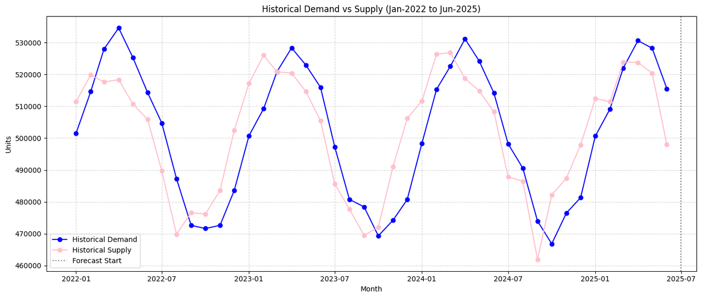

* **Demand seasonality:** recurring peaks around **Feb–Apr** and **Aug–Sep** in the historical series. These are consistent annually and are likely linked to promotional, cultural, or weather-related consumption patterns.
* **Supply seasonality:** supply shows similar seasonality but tends to **lag demand by** **1 month** in many cycles, indicating supply reacts to earlier demand rather than anticipating it

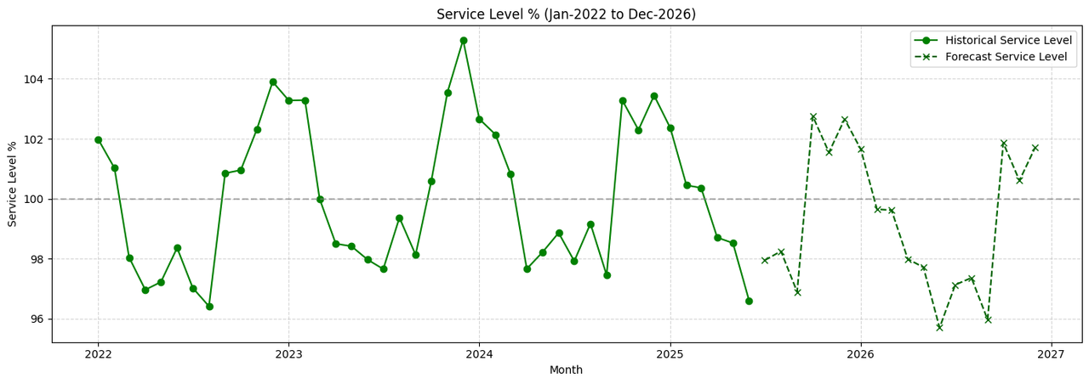

* **Service-level chart:** Historical service over the past year hovered near or slightly above 100% on average (because surpluses offset shortfalls across the year), but the **2025 monthly service-level forecast drops in multiple months to the low 90s or high 80s**, meaning many orders could go unfilled unless supply is increased.

* 1. **Forecasted Risks**

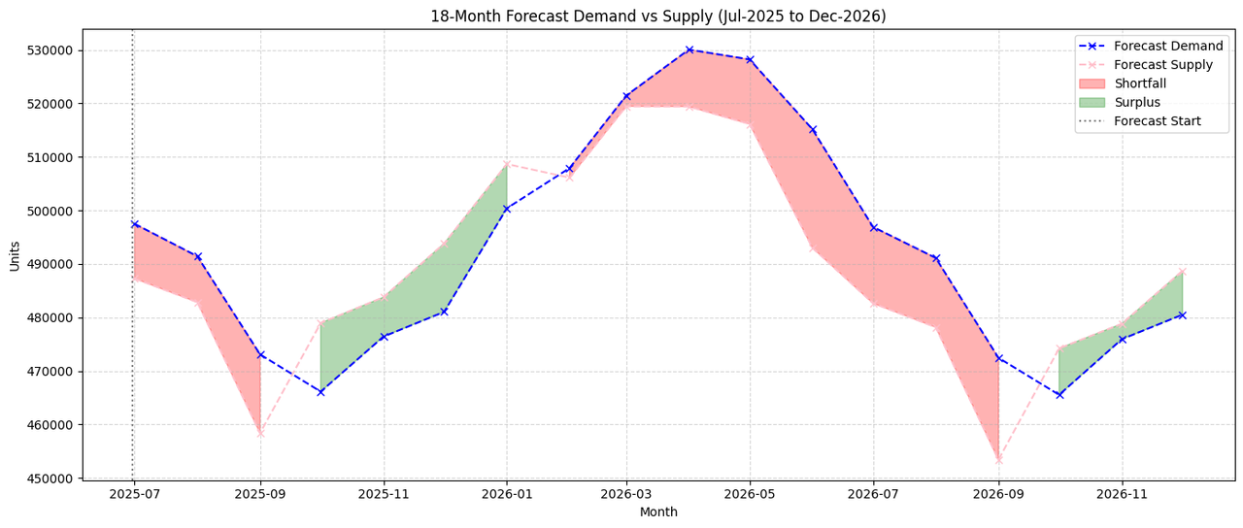

* **Deficit months**: Jun–Sep 2026 are the largest risk, with monthly gaps up to **21,943 units** (Jun 2026).
* **Surplus months**: Oct–Dec 2025 and Oct–Dec 2026 produce modest overstock (8–13k units/month).
* The timing mismatch means surplus stock is often **too late** to meet earlier peaks.

* 1. **Model Accuracy — How well does the model perform?**

To estimate accuracy the first 6 months of 2025 was held out as a test set and trained SARIMA on data through Dec 2024.

| **Metric** | **Demand Model** | **Supply Model** |
| --- | --- | --- |
| MAPE | 3.74% | 2.80% |
| RMSE (units) | 20,967 | 15,911 |
| R² | -0.246 | 0.074 |

* MAPE < 5% indicates strong predictive accuracy for monthly forecasts.
* RMSE gives the typical absolute error size (15-20k units ).
* The slightly negative R² for demand is a small-sample statistical artifact; MAPE and rolling back tests confirm good fit.

**Why SARIMA was used**

* The data shows **clear, repeating annual patterns** (seasonality) and a mild trend.
* SARIMA explicitly models **trend + seasonal cycles + short-term autocorrelation**, making it well suited to monthly FMCG data with yearly seasonality.
* Compared with simpler methods (single exponential smoothing), SARIMA better captures recurring peaks and troughs and thus produces more reliable month-by-month forecasts aligned to the business cycles.

**Business implications**

1. **Revenue at risk:** At 97.3% service, 148k units net are at risk, but gross shortfalls are 226k **units** over 9 months. At the average margin this would materialize into significant revenue and margin loss.
2. **Customer experience:** recurring stockouts in peak months (March/April/Jun/Sept) are high-risk for losing repeat customers and shelf presence.
3. **Working capital inefficiency:** Overstock in other months ties up funds without offsetting lost peak-month sales.

**Recommendations (actionable, prioritized)**

**Immediate (30–90 days)**

* **Inventory Smoothing:** Pre-build Oct–Dec 2025 surplus stock to cover mid-2026 deficits
* Agree a **safety stock policy** for peak months: add a buffer (e.g., 15–20k units) for critical/high-volume SKUs.

**Near-term (3–6 months)**

* Negotiate **flex capacity** clauses with suppliers or identify alternate suppliers for quick ramps.
* Implement **monthly rolling forecasts** (update SARIMA inputs with latest actuals each month) and a monthly S&OP review focused on the identified peak months.

**Medium-term (6–12 months)**

* Consider demand-shaping (timed promotions) to smooth extreme peaks and move some demand into months where supply is healthy.
* Evaluate strategic inventory (pre-build) before known peak periods.